Web Client User Manual

1：install Active-x
1.Input user name and password to log in (When first access, need to download the Active-X)：
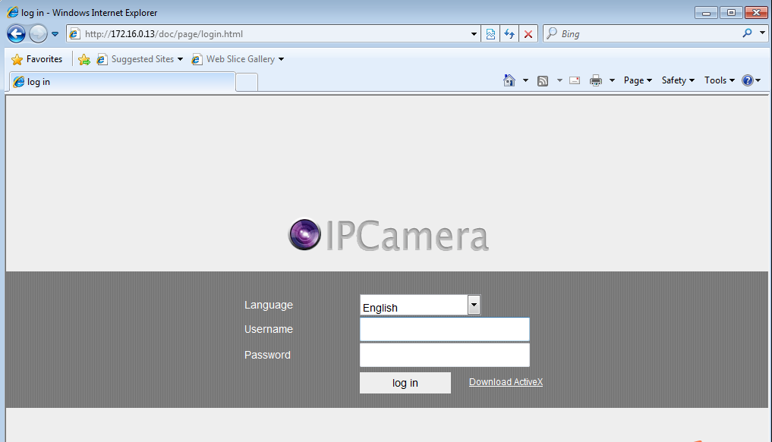
- Choose a language，Input user name and password to log in，Automatically prompt to install Active-x,Click “Install” to complete the Active-x installation.
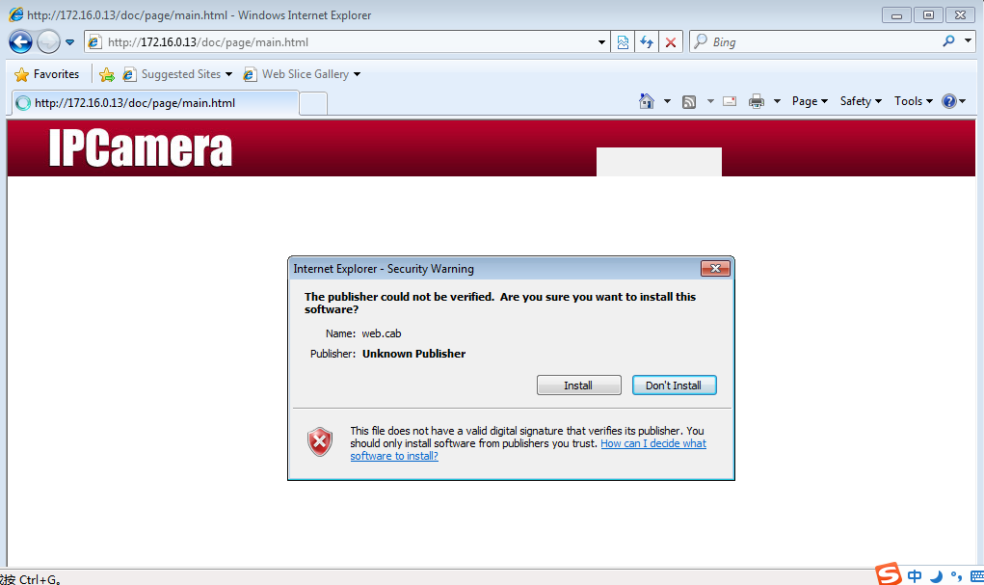
When finished installation, it will appear a file folder named Web client in C:\Program Files \IPCWeb. It is the downloaded file. If delete the file, will result in unable to log in the Web client. You should download again.

- If you are not prompted to install the control, click " Download Active X"
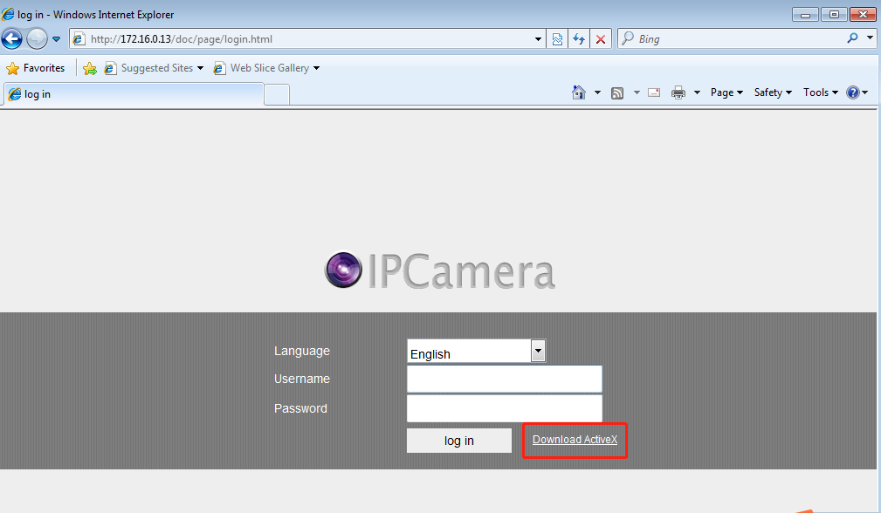
The file will be downloaded in C:\Users\Administrator\Downloads \TSIPCWebClient_EN_SetUp.exe,Double click to run this program

Problem resolved:
1.Question：Why I cannot install the control?
Answer：Your IE browser intercept the installation，you need change the settings in IE Internet. choose the security option.
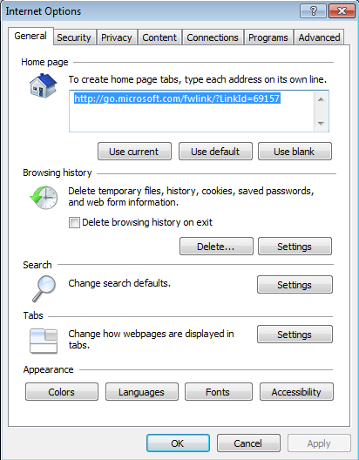

Choose “Security”
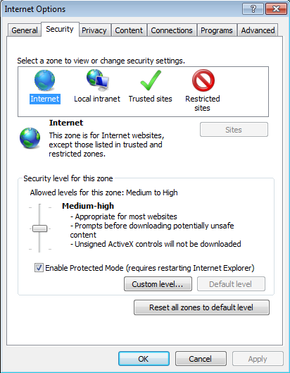

Choose “Custom Level”，Enable “Download unsigned Active X controls”
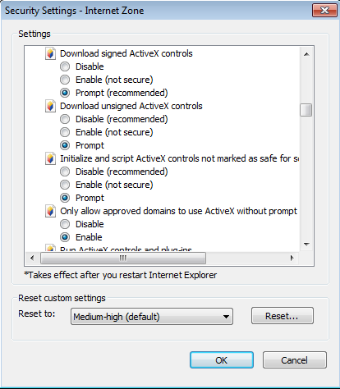

Then Re-enter the IP address of device, choose“install Active-X controls”；
Note：enter the user name and password of device，click log in to access web client.

2. Question：I have already downloaded the controls, why I still cannot log in Web client?
Answer：please check if the network is normal，or if the IP conflict with other device.
2：web client operation
Preview interface：
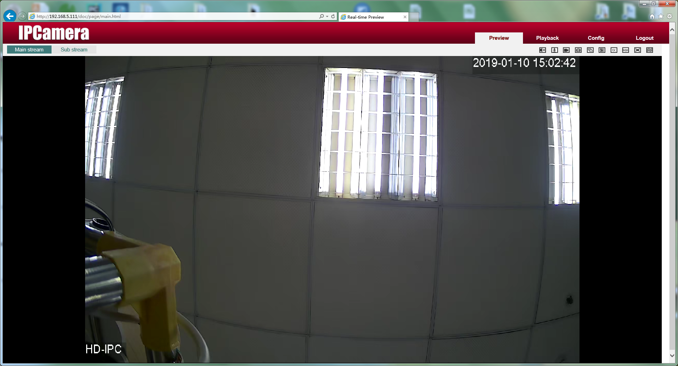
Preview interface |  | Select Main stream or Sub stream to play video
Preview interface |  | Input on the device, turn on the switch, you can hear the sound
Preview interface |  | Turn on the switch, the device and the web can talk
Preview interface |  | Record：Record local recordings and save them in C:\Record
Preview interface |  | Capture the preview screen and save it in C:\Picture
Preview interface |  | Continuously capture three pictures and save them in C:\Picture
Preview interface | 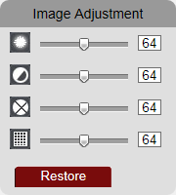 | adjust the screen brightness /contrast /saturation/color tone  Restore：The color setting value is restored to the default value.
Preview interface |  | Original resolution display
Preview interface |  | Suitable for display resolution
Preview interface |  | Full-screen display
Preview interface |  | fluency

Playback interface：
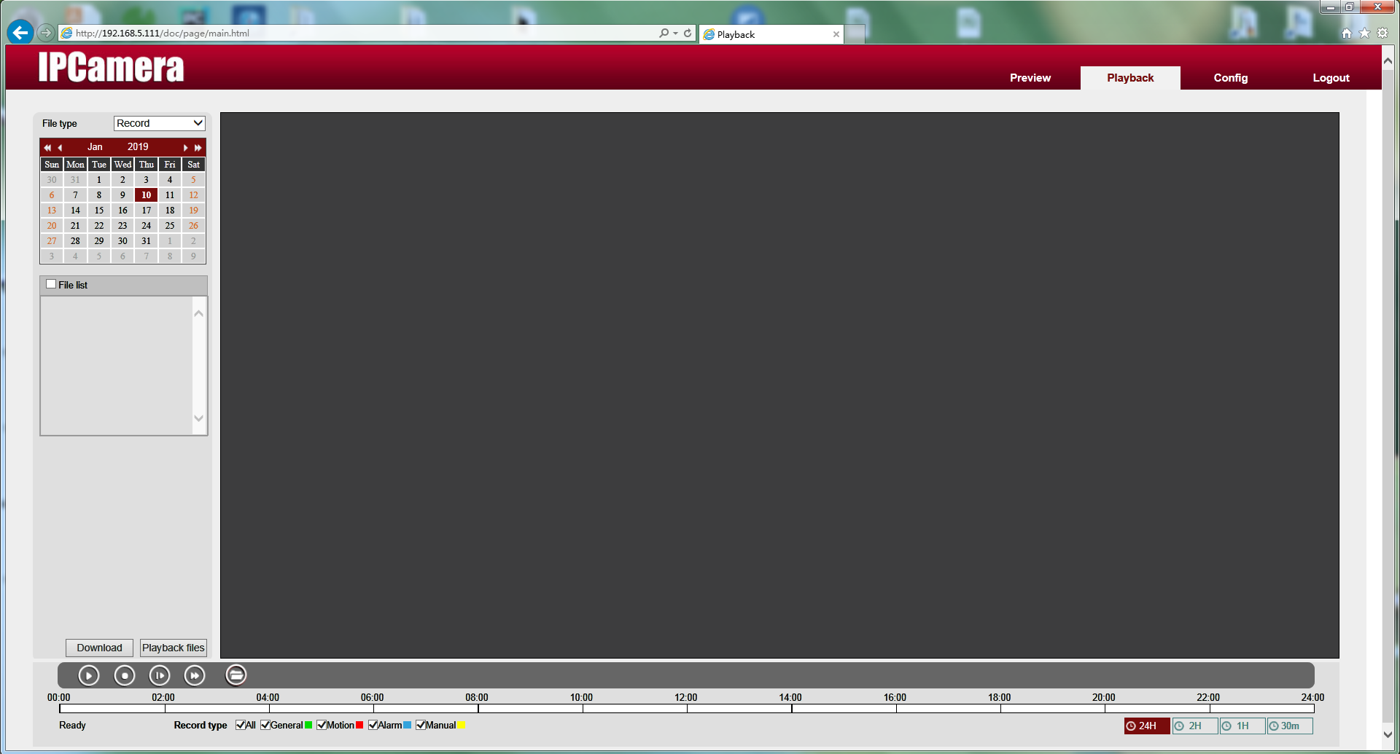
Playback interface | 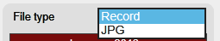 | Select the type of playback file
Playback interface | 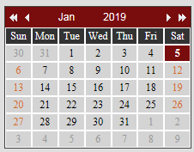 | Select the playback date, The default is the current date
Playback interface | 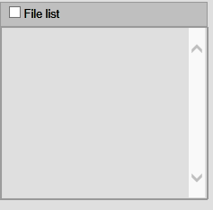 | Display videos or pictures saved in the TF card
Playback interface |  | Download the video file to a local folder
Playback interface | 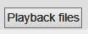 | Play the video files
Playback interface |  | Start playback
Playback interface |  | Stop playback
Playback interface |  | Slow playback
Playback interface |  | Fast playback
Playback interface |  | Play local video files
Playback interface | 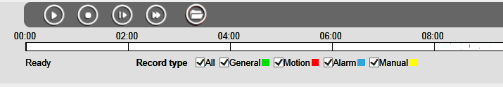 | Show different recording categories

Configuration interface：
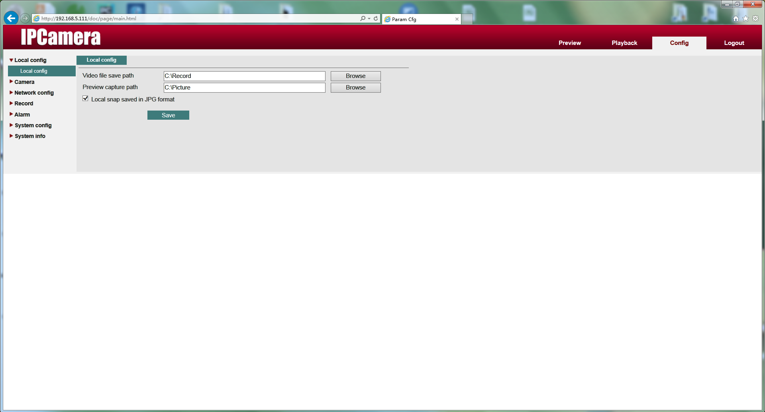
Configuration interface | Local Config | Set the save path of the video and capture file. Capture file format (bmp, jpg)
Configuration interface | Camera - Encode Config - Encode setting | Set camera encoding, resolution, frame rate, code stream and other parameters
Configuration interface | Camera - Encode Config - Snapshot | Set the size, quality, and capture frequency of the image
Configuration interface | Camera - Output model - Output model | Set display time and channel title
Configuration interface | Camera - Output model - Display config | Set image properties, camera parameters, ISP parameters
Configuration interface | Camera - Output model - Precover | Set the video Precover area
Configuration interface | Network Config -TCP/IP | Set the device's IP, port, etc.
Configuration interface | Network Config -Net service | Set Email, DDNS, RTSP, FTP, UPnP, P2P, IPfilter functions
Configuration interface | Alarm - Alarm config | Set motion detection alarm, occlusion alarm, alarm input, alarm output, abnormal alarm
Configuration interface | System config - System config - System config | Set the hard disk full state, device name, automatic logout time
Configuration interface | System config- System config - General config | Set the time display mode on the preview screen
Configuration interface | System config- System config - NTP Setting | Set NTP timing
Configuration interface | System config - System Tool - User | Add, modify, delete users, modify the device password in the modify user, add, modify, delete group
Configuration interface | System config - System Tool - Auto Maintain | Set automatic restart time and automatically deleted files
Configuration interface | System config - System Tool - System Maintain | Restore the device to factory settings and default settings;  Import and export of parameters of the configuration file;  Upgrade the firmware of the device
Configuration interface | System Info - System Info | View the version information, web version, extension information, release date, MAC address, and serial number of the device.
Configuration interface | System Info - Log Info | View device operation information

